**Traffic Shifting**

**Apply weight-based routing**

route all traffic to the v1 version



Open the Bookinfo site

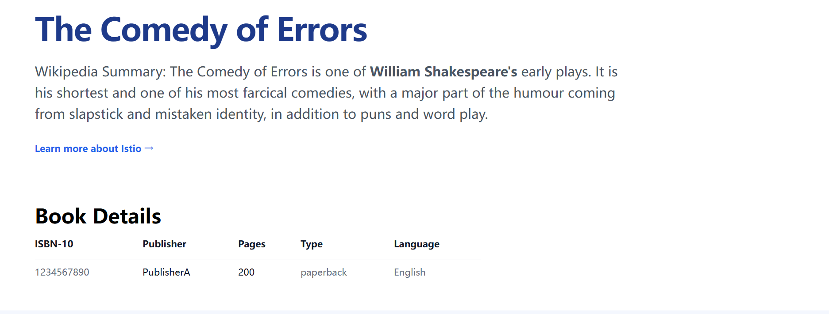

Transfer 50% of the traffic from reviews:v1 to reviews:v3



confirm the rule was replaced

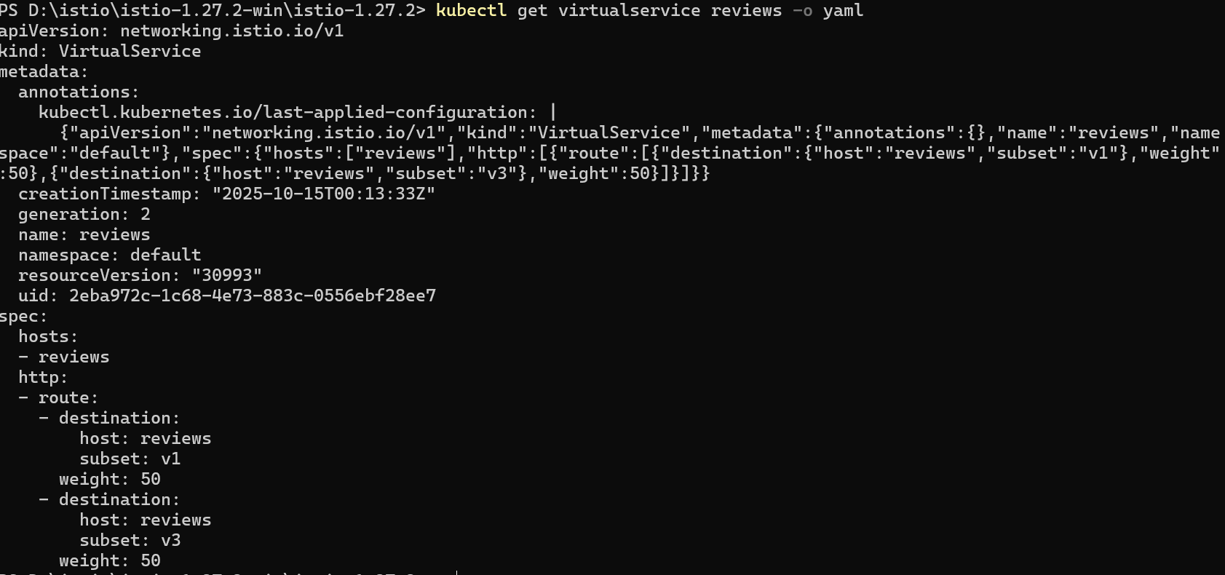

route 100% of the traffic to reviews:v3



